DCC-GARCH correlation: USDCHF and USDCAD
Method 09 / GARCH(1,1) + Engle DCC / Alpari D1 full available history

Study setup
Logical pair: USDCHF , USDCAD
Broker symbols: USDCHF_i , USDCAD_i
Snapshot: 2026-11-03_majors_alpari_D1
Timeframe: D1
Matched return window: 1999-01-05 to 2026-11-02 (UTC bar dates)
Matched return count n: 7188
Dropped unfinished last bar dated 2026-11-03 UTC after a tick-volume check against the prior complete day.
USDCHF GARCH(1,1): mu=-0.000342, omega=0.003468, alpha=0.040954, beta=0.956741
USDCAD GARCH(1,1): mu=-0.000009, omega=0.001259, alpha=0.043622, beta=0.951229
DCC: a=0.020250, b=0.977974, a+b=0.998225
Burn-in ignored in path summaries and chart: first 60 updates
Complete matched rows (Excel): USDCHF-USDCAD_DCC_D1.xlsx
Complete matched rows (HTML table): USDCHF-USDCAD_DCC_D1_data.html

Method carried forward
DCC-GARCH first fits a constant-mean GARCH(1,1) on each matched daily log return of close, ln(close_t / close_t-1), then updates Engle (2002) dynamic conditional correlation on the standardised shocks z = residual / conditional sigma. Quotes are not inverted. Correlation targeting sets Q_bar to the sample correlation of z; a and b are estimated by maximising the bivariate Gaussian DCC likelihood with a >= 0, b >= 0, and a + b < 1. Path summaries ignore the first 60 updates. The headline is rho on the last day. Same-sample Pearson r on log returns is a side check only. A high |rho| does not prove cause, lead-lag, or a trading signal.

Results
Latest DCC rho: 0.581011
Post-burn-in path (n=7128): mean=0.324376, median=0.346942, min=-0.295819, max=0.705355, std=0.186387
Share of post-burn-in days with |rho| >= 0.4: 37.67%; |rho| >= 0.7: 0.06%
Same-sample Pearson r: 0.304665
Latest rho minus r: 0.276345

Conclusion
Over 7188 matched daily log-return rows for USDCHF and USDCAD (broker quote directions unchanged), latest DCC rho is 0.5810 (positive, moderate conditional linear link in this sample) with fitted a=0.0203, b=0.9780 (a+b=0.9982). After a 60-day burn-in, path mean is 0.3244 and std is 0.1864. Same-sample Pearson r is 0.3047 (latest rho minus r = 0.2763). This does not establish cause, lead-lag, or a lasting trading rule.

Charts
Daily closes

Daily log returns
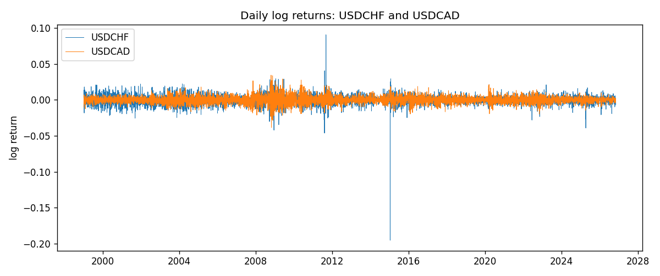
DCC rho path with Pearson r reference
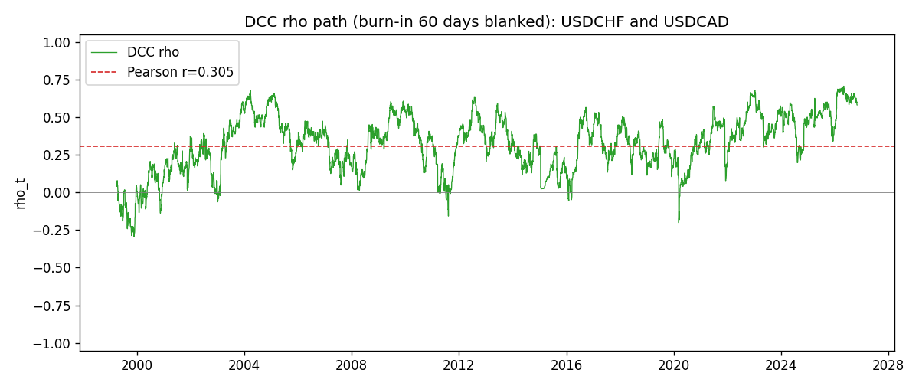

Data report
Every matched row that entered the DCC recursion is stored in the sibling Excel workbook named USDCHF-USDCAD_DCC_D1.xlsx. Embedding all rows as a Word table is impractical at this length; the Word file holds the column list, column summaries, and the first and last 15 matched rows.
Columns: time, USDCHF_open, USDCAD_open, USDCHF_high, USDCAD_high, USDCHF_low, USDCAD_low, USDCHF_close, USDCAD_close, USDCHF_tick_volume, USDCAD_tick_volume, USDCHF_spread, USDCAD_spread, USDCHF_real_volume, USDCAD_real_volume, USDCHF_log_return, USDCAD_log_return, USDCHF_sigma, USDCAD_sigma, USDCHF_z, USDCAD_z, q11, q22, q12, rho_t
Column summaries (matched calculation rows)
column | count | mean | std | min | 25% | 50% | 75% | max
USDCHF_open | 7188 | 1.0975966 | 0.25229688 | 0.72022 | 0.9205375 | 0.989955 | 1.2378 | 1.8219
USDCAD_open | 7188 | 1.2667824 | 0.16892678 | 0.9168 | 1.1183975 | 1.298465 | 1.3720475 | 1.6183
USDCHF_high | 7188 | 1.1028875 | 0.2540352 | 0.73305 | 0.924845 | 0.993545 | 1.242375 | 1.8313
USDCAD_high | 7188 | 1.2716804 | 0.16888565 | 0.9336 | 1.12285 | 1.30387 | 1.37646 | 1.619
USDCHF_low | 7188 | 1.0924772 | 0.25071604 | 0.08565 | 0.91725 | 0.9863 | 1.23155 | 1.8121
USDCAD_low | 7188 | 1.2622243 | 0.16896256 | 0.9056 | 1.114065 | 1.293535 | 1.3677775 | 1.6102
USDCHF_close | 7188 | 1.0975873 | 0.25219296 | 0.72025 | 0.920805 | 0.98995 | 1.2379 | 1.8217
USDCAD_close | 7188 | 1.2667976 | 0.16890032 | 0.916 | 1.118075 | 1.29844 | 1.372365 | 1.6137
USDCHF_tick_volume | 7188 | 74305.244 | 113479.97 | 1 | 12787.25 | 40220 | 70419.75 | 858589
USDCAD_tick_volume | 7188 | 81017.898 | 147302.44 | 1 | 5560 | 40941.5 | 71627 | 1410818
USDCHF_spread | 7188 | 26.050501 | 24.7086 | 0 | 5 | 16 | 50 | 100
USDCAD_spread | 7188 | 23.4399 | 18.261108 | 0 | 9 | 17 | 40 | 60
USDCHF_real_volume | 7188 | 2.3284369e+10 | 8.9116261e+10 | 0 | 0 | 0 | 0 | 1.9331921e+12
USDCAD_real_volume | 7188 | 1.8376704e+10 | 9.6688094e+10 | 0 | 0 | 0 | 0 | 2.5751613e+12
USDCHF_log_return | 7188 | -7.133e-05 | 0.00659527 | -0.19545699 | -0.0033544 | 8.077e-05 | 0.00332477 | 0.09051364
USDCAD_log_return | 7188 | -1.556e-05 | 0.00514382 | -0.03859748 | -0.00283746 | 4.44e-05 | 0.00272629 | 0.03436319
USDCHF_sigma | 7188 | 0.00655211 | 0.00254561 | 0.00362103 | 0.00508761 | 0.00611038 | 0.00731757 | 0.03987635
USDCAD_sigma | 7188 | 0.00479489 | 0.00181328 | 0.0025109 | 0.00364892 | 0.00435952 | 0.00535062 | 0.01852279
USDCHF_z | 7188 | 0.03923134 | 0.99910573 | -34.46962 | -0.482871 | 0.07030133 | 0.59718743 | 6.7485143
USDCAD_z | 7188 | 0.00164982 | 1.0000914 | -4.0688676 | -0.62843993 | 0.00913085 | 0.61324519 | 6.4151667
q11 | 7188 | 1.0012622 | 1.3322891 | 0.4635749 | 0.74965779 | 0.84954521 | 0.95909093 | 24.877905
q22 | 7188 | 1.0014188 | 0.1655215 | 0.63855825 | 0.89546229 | 0.97870264 | 1.0779107 | 2.037063
q12 | 7188 | 0.29860155 | 0.18040621 | -0.27419413 | 0.17542986 | 0.30249729 | 0.42368955 | 0.85945015
rho_t | 7188 | 0.32226963 | 0.18711839 | -0.29581854 | 0.19429077 | 0.34572964 | 0.45933978 | 0.70535526
First 15 matched rows (selected columns)
time | USDCHF_log_return | USDCAD_log_return | USDCHF_sigma | USDCAD_sigma | USDCHF_z | USDCAD_z | q11 | q22 | q12 | rho_t
1999-01-05 | 0.0039424743 | -0.010131666 | 0.0083864494 | 0.0045199748 | 0.51082839 | -2.2395101 | 1 | 1 | 0.29958445 | 0.29958445
1999-01-06 | 0.013605652 | -0.0003306769 | 0.0082697309 | 0.0049019807 | 1.6865379 | -0.065593976 | 0.98503392 | 1.0813132 | 0.27035131 | 0.26195527
1999-01-07 | -0.0093883841 | 0.0015202092 | 0.0085873984 | 0.0047945639 | -1.0534997 | 0.31897492 | 1.0227134 | 1.059359 | 0.26268829 | 0.25237257
1999-01-08 | 0.011040268 | -0.0020495197 | 0.0086169619 | 0.0047004881 | 1.3208635 | -0.43407902 | 1.0244379 | 1.0398617 | 0.25062937 | 0.24282946
1999-01-11 | 0.0052963193 | -0.0035137769 | 0.0087574085 | 0.0046178433 | 0.64378423 | -0.75893447 | 1.0389796 | 1.022549 | 0.23403027 | 0.22705258
1999-01-12 | -0.0098275602 | 0.0066194721 | 0.0086615896 | 0.0045766919 | -1.0951798 | 1.4483406 | 1.0262637 | 1.0134659 | 0.21951338 | 0.21524197
1999-01-13 | -0.018259701 | 0.0045420214 | 0.0087068782 | 0.0046869072 | -2.0579292 | 0.97103648 | 1.0297235 | 1.0353978 | 0.18308943 | 0.17731657
1999-01-14 | -0.0024256692 | 0.0069376546 | 0.0092750078 | 0.0046824299 | -0.22470137 | 1.4835868 | 1.09458 | 1.0334621 | 0.13912196 | 0.1308051
1999-01-15 | 0.01794228 | -0.0056905671 | 0.0091010479 | 0.0048048742 | 2.0089821 | -1.1824307 | 1.0732689 | 1.0570463 | 0.12983888 | 0.12189993
1999-01-18 | -0.0031856384 | 0.00098344542 | 0.009658347 | 0.0048471409 | -0.29446821 | 0.20477678 | 1.1331353 | 1.0638523 | 0.079406743 | 0.072322901
1999-01-19 | -7.2518946e-05 | 0.002748513 | 0.0094829525 | 0.0047452867 | 0.028371252 | 0.58113443 | 1.1117085 | 1.0430448 | 0.076968559 | 0.071477017
1999-01-20 | 0.0072259871 | -0.0059646885 | 0.0092944089 | 0.0046772985 | 0.81420447 | -1.2732889 | 1.089014 | 1.0286852 | 0.076139053 | 0.07193653
1999-01-21 | -0.0038232689 | -0.0042823796 | 0.0092380311 | 0.0047416485 | -0.37688839 | -0.90121466 | 1.0802276 | 1.0406342 | 0.054000093 | 0.050931659
1999-01-22 | -0.0001445609 | 0.0025057712 | 0.0090825496 | 0.0047232539 | 0.021690087 | 0.53245235 | 1.0610867 | 1.035936 | 0.060220775 | 0.057438681
1999-01-25 | 0.0024546976 | 0.00085579808 | 0.0089035135 | 0.0046500373 | 0.31406251 | 0.18600594 | 1.0395004 | 1.0206352 | 0.059660146 | 0.057921087
Last 15 matched rows (selected columns)
time | USDCHF_log_return | USDCAD_log_return | USDCHF_sigma | USDCAD_sigma | USDCHF_z | USDCAD_z | q11 | q22 | q12 | rho_t
2026-10-13 | -0.0024955621 | -0.0046395653 | 0.0047788457 | 0.0028878358 | -0.45073644 | -1.6034253 | 0.72095818 | 0.80658382 | 0.45989871 | 0.60309038
2026-10-14 | 0.0029388325 | 0.0015184751 | 0.0047314107 | 0.0029990037 | 0.69332274 | 0.50937302 | 0.71096811 | 0.84265664 | 0.46493632 | 0.60067989
2026-10-15 | -0.0097855323 | -0.0036101503 | 0.0047122537 | 0.0029636177 | -2.0041302 | -1.2150737 | 0.70681821 | 0.83112611 | 0.46237923 | 0.60326898
2026-10-16 | -0.0036230826 | -0.0034322068 | 0.0050243582 | 0.0030076892 | -0.65312232 | -1.1381064 | 0.7743616 | 0.84449302 | 0.50203973 | 0.6208235
2026-10-19 | 0.0036351779 | -0.0018835331 | 0.0049939899 | 0.0030400659 | 0.79630521 | -0.61656447 | 0.76771931 | 0.85389783 | 0.50656632 | 0.62565098
2026-10-20 | -0.0026281224 | -0.0037066008 | 0.0049855304 | 0.0030117068 | -0.45863931 | -1.2276973 | 0.76542593 | 0.84456373 | 0.48599834 | 0.60445919
2026-10-21 | -0.00040027413 | -0.00084691787 | 0.0049336802 | 0.0030578154 | -0.011900234 | -0.27398037 | 0.75460196 | 0.85825912 | 0.48722809 | 0.60543029
2026-10-22 | -0.0048036381 | -0.0026307268 | 0.0048615999 | 0.0030084365 | -0.91782047 | -0.87141289 | 0.73975961 | 0.84265086 | 0.47709444 | 0.60427581
2026-10-23 | 0.005652514 | 2.85545e-05 | 0.0048759521 | 0.0030058179 | 1.229314 | 0.012539347 | 0.74230005 | 0.84124358 | 0.48331417 | 0.61161608
2026-10-26 | 0.0018407959 | 5.7106554e-05 | 0.0049562743 | 0.0029530015 | 0.44032231 | 0.022432446 | 0.75832832 | 0.82449319 | 0.47351285 | 0.59883833
2026-10-27 | 0.0026100526 | 0.0025379458 | 0.0049034531 | 0.0029018913 | 0.60194616 | 0.87773179 | 0.74732723 | 0.80811875 | 0.46381528 | 0.59683194
2026-10-28 | -0.0010142111 | -0.0038379274 | 0.0048690164 | 0.0029015749 | -0.13814883 | -1.3195561 | 0.73997973 | 0.80769589 | 0.46483048 | 0.60125784
2026-10-29 | -0.0048680164 | -0.00011436495 | 0.0048007379 | 0.0029620723 | -0.94286634 | -0.035525284 | 0.72584306 | 0.82694164 | 0.45881566 | 0.59221505
2026-10-30 | 0.00071594559 | -0.0010298736 | 0.0048203711 | 0.002910722 | 0.21938306 | -0.35068175 | 0.72963374 | 0.81052864 | 0.44992008 | 0.58505776
2026-11-02 | -0.0071459744 | 0.00061519094 | 0.0047564063 | 0.0028688688 | -1.4305784 | 0.21762147 | 0.71631309 | 0.79694193 | 0.43898421 | 0.58101068

